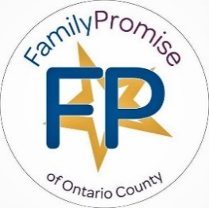 | Family Promise Ontario County News  Fall 2022 | March 2022

Thank you for helping
my mom find us a home.

Clayton and Family Promise Redefine How Corporations Help Prevent Family Homelessness
We first partnered with Clayton in 2021 when we launched A Future Begins at Home, an innovative prevention program that addresses the underlying causes of family homelessness and catalyzes funding from other sources to increase reach and impact.
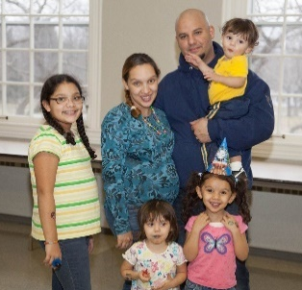
Since the program's inception, Family Promise affiliates across the country have served over 5,100 families facing housing insecurity, including over 11,300 children. In 2022, funding from Clayton aims to prevent 1,000 families and more than 2,400 children from becoming homeless.
Corporate sponsorship of the Ontario County Bed Race raised the matching funds needed to receive a $10,000 Grant from Clayton to prevent homelessness for those facing eviction, and

$10,000 to increase the number of landlords who will house FPOC program graduates charging fair market rent. Our continued partnership will allow us to significantly increase our impact.
Our landlord engagement program helped us partner with Joseph Furmansky, of FLX Properties. Using grant funds, a three-apartment property is being remodeled for Family Promise graduates to move into as Permanent Supportive housing.
Together, we can end family homelessness.

The Housing Crisis
The Housing Crisis Expands
Family Promise National

Child Homelessness: A Growing Crisis | SAMHSA

“Family homelessness is exploding because the demographics of the family have changed,” Dr. Bassuk said. “There’s a rise in female-headed households and poverty, an expansion of the low-wage economy, lack of affordable housing, increased levels of violence against women, and cuts in human service programs.
www.samhsa.gov/homelessness-programs-resources/hpr-resources/child-home…

New homes needed by the millions as inflation adds to lack of affordable construction

The housing crisis continues to feel the impacts of the lag in new home construction that began during the 2008 market crash. Recent data from Realtor.com reveals the need to build new homes by the millions to meet current demands. At present, inflation, supply chain issues, and zoning restrictions continue to exacerbate the lack in supply of new homes. The National Association of Homebuilders reports costs for building materials are up by 31.3% since January 2020. (Business Insider)

Spikes in food prices force many to reevaluate their grocery budget

Food costs have seen their biggest year-over-year spike in 43 years from last summer, as groceries are now 12.2% higher than they were a year ago. The Washington Post recently conducted numerous interviews of a diverse group of consumers who have changed or reduced their purchasing habits due to inflated prices. From economical meal prepping to cutting out certain items altogether, grocery buyers in all age and income categories have been forced to stretch their food budgets through reimaging their pantries and forgoing former indulgences. (The Washington Post)

Affordable, Accessible, Inclusive

The Town of Canandaigua Affordable, Accessible, Inclusive Housing Committee has met for a year to identify available land to build mult-unit housing for working families. Pathstone will be constructing 46 multi-income units next to the Trolley Station Apt. building in uptown Canandaigua. The DiMarco Group is expected to begin building the next phase of income-based apartments next to their existing apartments. They currently have a waiting list of over 100 families. This is a start, but does not address the housing needs of 131 Ontario County homeless families on the Coordinated Entry List (a list that prioritizes the vulnerability of each family or individual and places them on a waiting list) for housing assistance. Family Promise shelters the most vulnerable families. “There are so many calling, said Brenda Spratt, Executive Director.
I am just trying to get these kids out of cars.
I can’t imagine what is more important than this. Is this what a resort community will cost us?

No Full-Time Worker Can Afford Housing on a Minimum Wage Salary

BY ROBERT DAVIS | AUGUST 23, 2022 | AFFORDABLE HOUSING
A new report from the National Low Income Housing Coalition (NLIHC) shows that no full-time worker making minimum wage in the U.S. can afford housing.
According to the report, nationwide rent increases have made it difficult for low-income earners to keep their homes. This has dramatically increased the risk that these households could experience homelessness.
Meanwhile, the cost of living continues to climb as inflation pushes up consumer prices, making it more expensive for low-income families to stay in their homes.

“As a country, we have the data, partnerships, expertise, solutions, and means to end homelessness and housing poverty – we lack only the political will to fund solutions at the scale necessary,” Yentel continued.
The latest inflation data from the Bureau of Labor Statistics shows that consumer prices have increased by 9.1 percent, impacting the cost of groceries, household energy, housing, and transportation.

The disparities are even starker along gender lines. For instance, 70 percent of Black and Latina women do not earn enough to afford a one-bedroom apartment.
The average hourly wage for Black and Latino workers was $6 per hour less than their white counterparts.
Housing discrimination will keep the majority of these families from emerging out of poverty.

Ontario County Median Income

New data from the United Way of Greater Rochester/Ontario County shows the median area income is $62,628.
Number of people living below the federal poverty level in Ontario County
is 11,148 or 9%

The median income is the income amount that divides a population into two equal groups, half having an income above that amount, and half having an income below that amount. Data: Wikipedia

Why is Median Income important?

Each year the government evaluates the funding a county receives based on a number of factors, among them, median income.

Because there are many affluent landowners on the lakes, they push the overall median income and average home prices up. Ontario County demographics give the overall impression that we have less people at and below the poverty level.

It looks like we have less people in-need and consequently receives less government funding to support programs for low-income workers earning minimum wage. These workers are vital in the region working in vineyards, farms, hotels and restaurants. This results in fewer housing vouchers and more families evicted to the street.
Housing Discrimination

Housing discrimination forces families experiencing homelessness to live in cars, hotel rooms, campgrounds and shelters.

Ontario County does not have a shelter for homeless individuals and families.
Family Promise’s apartment shelter program stabilizes families so they can be successful in the community. We have a waiting list of over 150 families this year that have called for help.

- Raising rents to keep lower income families out of housing is redlining & discrimination.

- Forcing a family out of housing so you can fix up a rental and can charge more rent is unconscionable and can be housing discrimination.

- Raising rents of single mothers with children who were barely getting by on their own, and now cannot afford to remain in their housing or secure new housing, is NOT discrimination. (But stinks!)

- Advertising apartments that are not available and collecting application fees when there are no available units is false advertising and is illegal.

What do I do if I experience discrimination based on my source of income?
If you experience source of income discrimination, you can take action. Report it to the NYC Commission on Human Rights by dialing 311 and asking for “Human Rights,” call (212) 416-0197, or use our Report Discrimination form using the link printed below. Just enter it in your browser.

https://www1.nyc.gov/site/cchr/about/report-discrimination.page or
Contact LawNY for help: (315)781-1465

Rules Against Children

Discriminatory
John has three teenage children. John’s building has a patio with picnic tables, and one day John’s children decide to have lunch there with some of their friends. The next day, John receives a notice from the homeowners association informing him that the building rules say that the patio is for adult-use only and that he needs to make sure his children do not violate the building rules.
John files a complaint with HUD because building rules that discriminate against children are a form of familial status discrimination.

Current Ontario County
Housing Wait Lists:
Lack of Housing Inventory

- Family Promise’s has a waiting list of over 100 families needing emergency housing.

- The Finger Lakes Coordinated Entry System has 297 families that are homeless in the Region and 131 Ontario County families are on the
waiting list for housing help.

- Ontario County DSS reports their hotels are already full with homeless families and singles before Code Blue starts.

- Creekview, the newest income based rental units, are full and have 100 families on the waiting list.
It is illegal to refuse housing to anyone based on the source of their income. Income discrimination may sound like this:
- “We cannot rent to anyone with a voucher”

- “We do not accept Section 8”

- “We don’t accept payment from anyone who does not live in the unit” (meaning housing subsidies for elderly, disabled or poor families”.

All Teams for Family Promise Amazing Bed Race 2022

- Team Name Amount Raised
- FPOC - Board Members $3,500.00
- Shooting Stars - First Presbyterian Church in Victor $1,450.00
- Faith Believe Hope and Love $1175. Leonard’s Express $1,000.00
- Presbyterian Pirates – The Presbyterian Church in Geneva $650.00
- Powered by the Holy Spirit $500.00
- Sleep Tight...... $450.00
- Rock-a-bye Baby $100.00

Family Promise of Ontario County is a community initiative to help prevent, shelter and stabilize homeless families in Ontario County. This year we received more than 100 calls from families needing emergency housing.

Your support of the Amazing Bed Race helps ensure that we are here to help families reclaim their lives. We expanded the number of families we can serve by opening additional apartments.
We now operate 3 apartments in Canandaigua, 3 in Geneva and 1 in East Bloomfield as overnight program space for families. We have helped dozens of families in the past three years.

Our Case Managers work with each family to help
them navigate the crisis in their lives. Together with area organizations and the support of more than 40 congregations and over 700 volunteers we make change happen.

Watch for these upcoming fundraisers
  - Roc the Day! Tuesday after Thanksgiving
  - First Frost Annual Appeal- begins November 1
  - Year-end Giving- December 2022

Volunteering Is Back!!
Get ready for a whole new rollout
of opportunities.
We are building support for our shelter guests with services at our Day Centers at:
185 N Main St., Canandaigua and
Temple Beth El, Geneva Day Center
We need volunteers to help with:
- Telehealth Appts.
- Case Management meetings
- Classes: Budgeting &
Keys to good Tenancy
- Transportation to Appts.
- Household Furnishings for grads
- Group gathering for FPOC Graduates
- Prepare lunch at Day Center
- Process household
- Help with holiday gift giving

Day Center Project Team
One or more churches adopts our Day Center; helps us get our building ready to offer in-person classes and meetings; and takes on projects to make the center more welcoming and effective.

Ad hoc projects
could include painting, decorating, deep cleaning, rearranging furniture, etc.

Ongoing activities could include:
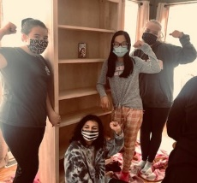
- Maintaining a diaper, food, and toiletry inventory
- Maintaining a library of children’s books
- Organizing donations
- Organizing and maintaining our nursery/playroom
- Minor building maintenance projects

Day Center Child Supervision Team
One or more churches builds a team of volunteers who read aloud to children, teach simple crafts, help with homework, and supervise play in the nursery area of our day center while parents meet with staff or attend virtual appointments.

Depending on the need we may try to schedule as many as ten volunteers each taking one morning or afternoon a week or recruit a smaller cadre of volunteers who could be available from time to time on shorter notice.

Apartment Hospitality Team
One church (or pod) adopts each of our seven emergency apartments. (United Church of Canandaigua is already taking care of our Saltonstall apartment.)

The team will clean and reset the apartment when a family moves out, offer hospitality to the new family for the duration of their residence with us, and then help arrange for a smooth transition to their new home when they graduate.

Driver Team
Recruit a group of volunteer drivers who can chauffeur guests and graduates to and from appointments, shopping trips, etc. Volunteer drivers may also coach guests about public transit, and even accompany them on the bus to help them become familiar with the routine.

Mother’s Helpers
Recruit a cadre of mother’s helpers who can provide help with tasks as varied as watching the kids in the apartment living room while mom is attending a remote meeting; helping clean the apartment; and teaching more effective ways to clean, shop, and cook.

Ideally, Drivers and Mother’s Helpers would be members of the guest’s hospitality team!

Staff Updates
Jay Garrett Larsen has moved from his Case Manager position to replace David Simmons as
the Community and Landlord Engagement position. Jay will be working with
landlords in the area to help secure housing for our graduates and will coordinate volunteers and congregations.
Jasmine VanBuren is our new grant funded Prevention Case Manager who is working with our waiting list to prevent homelessness. Jasmine is

Are You Looking for a leadership role on the Family Promise Board of Directors?

If you have a background in Marketing and Public Relations, housing law, special events or other skills and would like to volunteer on our Board or committees, please call Eileen Tiberio, Board President or Brenda Spratt, Executive Director at (585)905-3988.

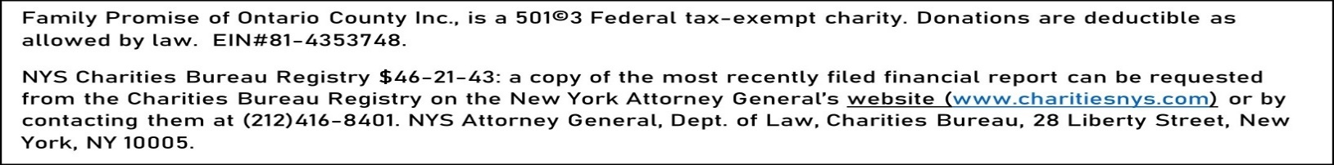
Brenda, I want to help move families into safe fairly priced housing.

finishing her degree in Human Services from Finger Lakes Community College in December 2022. She is completing her field placement at Family Promise and is working part time. She will begin full time January 1, 2023.
Welcome Glenda Pelham! She will be replacing Jay as the Shelter Manager and Geneva Case Manager.

Help Wanted – Paid Employment:
Driver – Monday-Friday 20 hrs. per week
Bilingual Case Manager – Full Time
Apply on Indeed.com

Ontario County Rents Skyrocket,

Unfair rental practices abound!
By Brenda Spratt, Executive Director FPOC

Reeling from the long stays families are experiencing in our shelter program because of the lack of affordable housing to move on to, I started calling through the available apartment communities in Greater Rochester and Ontario County who are currently advertising vacancies. Here is what I discovered:

- Most complexes have increased their rent, charging just above what assistance programs will pay for family housing. “They just raised my rent $320 per month”, said a man leaving the rental office we visited. I have nowhere to go now.” The recommended rate increase is 3-4%.

- Some we called were advertising vacancies when there were none and collecting application fees anyway. I inquired, why they are advertising a property that they don’t have available? Most blamed it on the advertisers for continuing the listing. Hmmm.

- Some said they had a vacancy but wouldn’t take Section 8.

At one complex in Canandaigua we were shown a refurbished unit that could be paid for using a housing voucher. But when we were ready to sign the
paperwork, the unit was no longer available, and the
one they had was an un-refurbished unit that was smaller and at a rent higher than the voucher would
pay, higher than what we were quoted, and not available for several weeks.

We also visited a second complex near Thompson Hospital that listed a three bedroom within fair market rent. When I told the manager that our guest had an emergency housing voucher, they told me that they only take rent payments if the funds came from a tenant (not DSS, Family Promise, SSI, Section 8, Emergency Housing Grants, etc.).

A third complex we went to is owned by a large company that has several apartment communities- all with different names and all advertising vacancies. The rental agent redirected us to an older property when they heard our guest had an emergency housing voucher.

False advertising, and redlining families are illegal practices. According to LawNY, In 1999 New York State passed a law that it is unlawful to refuse to rent to a family because of the source of their income.

We report all cases of housing discrimination to LawNY.

Family Promise of Ontario County
185 N Main Street
Canandaigua, NY 14424
Family Promise Newsletter Special Double Issue
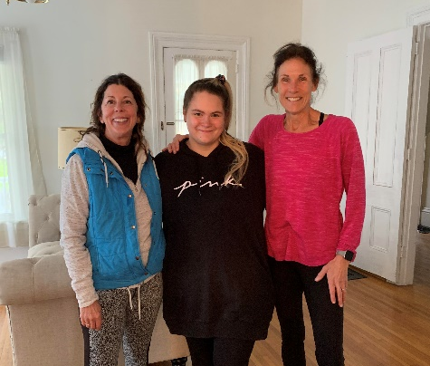

Congratulations to Leigh (left)
for being our Volunteer of the Month!
Working in the new E. Bloomfield
apartment with Jasmine (c) and Kelly (r)

Family Promise’s hospitality program stabilizes families so they can search for housing and employment.
Because every child deserves a home.

